Report for Multi-threaded Client-Server Model
CPS 356: Operating Systems
Group: Grant Harvey, Justin Spires, Quang Nguyen
December 2, 2024

1. Introduction
This project implements a multi-threaded client-server application using Python to simulate memory management and client-to-client communication in a concurrent environment. The application includes features such as user authentication, real-time messaging, and dynamic memory allocation using segmentation. The server uses sockets for communication and threading to handle multiple clients concurrently. The client uses threading to handle listening to the server and memory management.

2. Multi-threading Implementation
The server creates a dedicated thread for each connection. The Python threading library is used to manage threads, letting multiple simulations run and handle memory requests and chat messages. Each thread listens for client requests and processes them independently, enabling concurrent client operations. To handle access to shared resources, a monitor is used. The monitor will only allow one client at any time to access and modify shared resources. The threading.Condition() class is used to handle concurrent client access requests for shared resources.

3. Memory Management Strategy
The server simulates fixed-size segments of memory at 1 MB each, managed using first-fit segmentation. Segments are allocated in variable sizes using randomization, and the client requests and deallocates memory as needed. On receiving an allocation request, the server checks availability in the memory pool. If sufficient memory is available, the request is fulfilled, and the client receives the address of the allocated memory. Clients can free allocated memory by sending the address to be released, which updates the memory management tables. If the memory is ever unavailable, the server sends an error message to the client.

4. User Authentication
The server authenticates clients using a username and password. Client credentials are stored in a local JSON file with hashed passwords for security.
- Clients send their username and password over during the connection phase.
- The server verifies credentials against the JSON file.
- If authentication succeeds, the client gains access to server features.
- Failed authentication results in letting you try again or quitting the client application.

5. Client-to-Client Chat
Authenticated clients can exchange messages via the server. The chat feature uses a JSON-based protocol to structure messages, specifying the recipient and content. The message system works in the same way as the other server commands, using a keyword (in this case MESSAGE) followed by variable data split up with colons. In MESSAGE’s case, it is the recipient’s name followed by the message.
Example message:
{MESSAGE:Justin:Hello!}
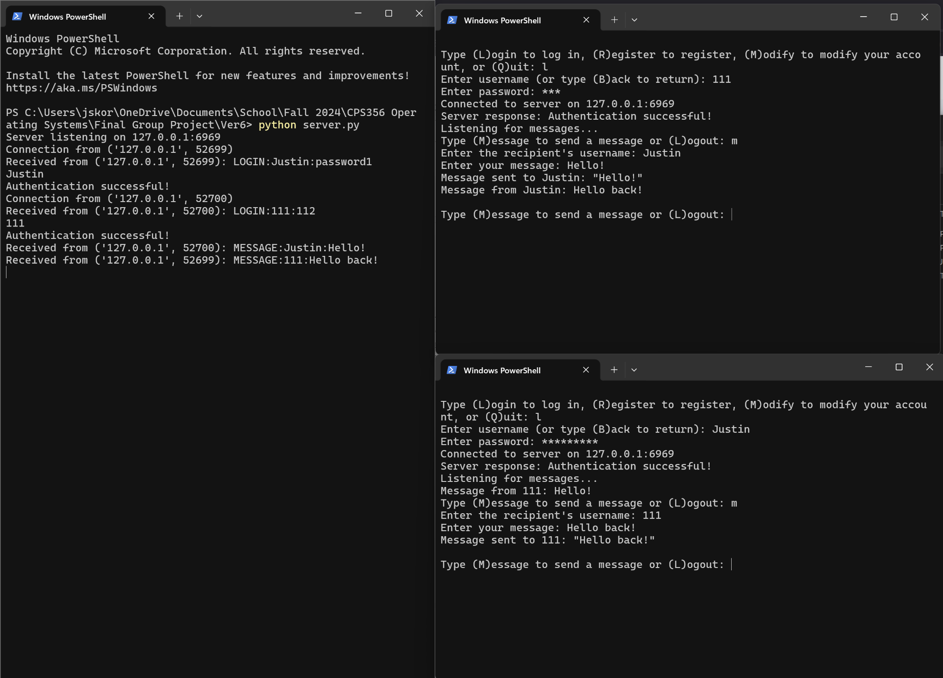

Figure 1. Demonstration of two clients communicating with the server

6. Communication Protocol
The application uses the Python socket library for server-client communication.
- Server: Listens for incoming connections and spawns a thread for each client.
- Client: Establishes a socket connection with the server to send and receive requests.

7. Conclusion
This project demonstrates the implementation of a multi-threaded client-server application with features such as real-time messaging, user authentication, and memory management. By leveraging Python’s threading and socket libraries, the project fulfills the requirements of concurrent handling, synchronization, and inter-client communication.

